CSA1413
COMPILER DESIGN
Name: M Praneeth
Reg No: 192324184
Frequence

Aim:
To write a Lex program to find the frequency of each word in a given input text.

Algorithm:
- Start the program.
- Include the required header files and declare arrays to store words and their frequencies.
- Read the input text using yylex().
- Identify each word using a regular expression.
- Check whether the word already exists in the array.
- If the word exists, increment its frequency; otherwise, store the word with frequency 1.
- Ignore whitespace and other characters.
- Display each word and its frequency.
- Stop the program.

Pseudocode:
BEGIN
Initialize word array and frequency array
Set n = 0
Read input text using yylex()
FOR each word matched in the input DO
Set found = 0
FOR i = 0 to n - 1 DO
IF word matches words[i] THEN
Increment count[i]
Set found = 1
BREAK
END IF
END FOR
IF found = 0 AND n < 100 THEN
Store word in words[n]
Set count[n] = 1
Increment n
END IF
END FOR
FOR i = 0 to n - 1 DO
Print words[i] and count[i]
END FOR
END

Code:
%{
#include <stdio.h>
#include <string.h>
char words[100][50];
int count[100];
int n = 0;
int i, found;
%}
%%
[a-zA-Z]+ {
found = 0;
for (i = 0; i < n; i++) {
if (strcmp(words[i], yytext) == 0) {
count[i]++;
found = 1;
break;
}
}
if (!found && n < 100) {
strcpy(words[n], yytext);
count[n] = 1;
n++;
}
}
[ \t\n]+ ;
. ;
%%
int main()
{
printf("Enter the input text (Ctrl+D to stop):\n");
yylex();
printf("\nWord Frequency:\n");
for (i = 0; i < n; i++) {
printf("%s : %d\n", words[i], count[i]);
}

return 0;
}
int yywrap()
{
return 1;
}
Input:
hello world hello
welcome hello world

Output:
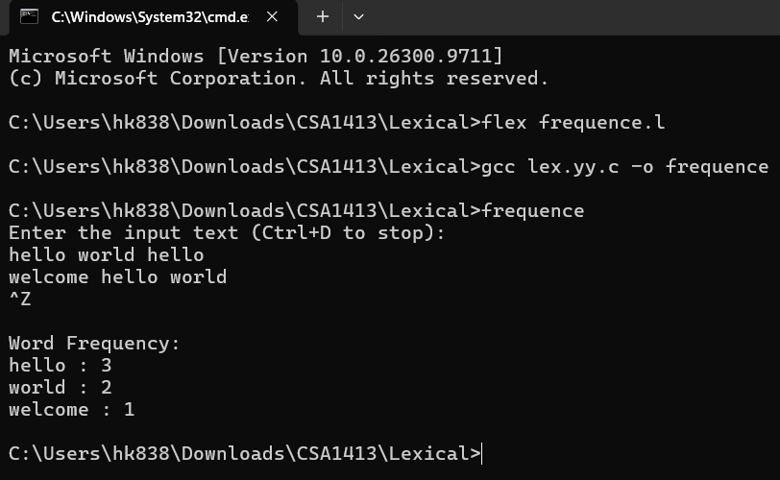

Result:
Thus, the Lex program to find and display the frequency of each word in the given input text was executed successfully.

